Managing Pastures and Fields for Wildlife
The benefits of proper land management are many. The primary purpose of the land (grazing or growing hay) is benefited by proper management practices. Insect populations are kept in check. The soil is improved. Species of native birds that are in population decline can take advantage of this niche and improve their numbers.
Attracting raptors is only part of the benefit of proper pasture management. And watching nature on your doorstep is sometimes the most rewarding of all the benefits. Providing habitat for grassland nesters and the intentional management of pasture and field can provide habitat for them and their food chain. Pasture management is more than ensuring the rotation schedules are set or that grass is allowed to grow and rest. Pasture management should include considering the entire ecology. | 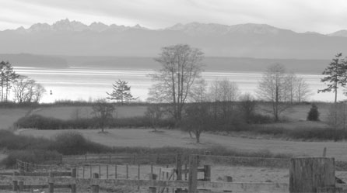  Fields with hedgerows supporting a variety of native wildlife
Small birds and mammals will nest in a location that has cover, food, and water. Beneficial to the population of these birds and mammals is to plant native plants that will ripen at various times throughout the year, especially those plants which bear seeds through the winter. Native grasses, millets, lespedezas, and clovers provide far more nutrition to these animals than just the pasture fescue or Bermuda grass. Plants such as clover fix the nitrogen in the soil and benefit the pasture as a whole.

Cover and travel lanes provide rabbits and ground nesting birds with safety, nest locations, and the ability to move around. The cover not only is a physical barrier against predators, it also regulates the temperature within the cover for the inhabitants. The cover does not need to be thick as many species prefer to see through the grasses. A few tall trees in a pasture provide shelter for the birds and perches from where raptors can hunt.

Rodents live in weedy areas and attract raptors. Large pastures with grassing for ground squirrels and mice attract Ferruginous hawks, Barn Owls, and Harriers. Rabbits, grouse, quail, and songbirds live well in pastureland with some cover. Mice and insects attract Kestrels.

Management Tips
- Make islands or hedgerow of shrubs, brambles, or woodpiles throughout grassy pastures. This also reduces the amount of mowing necessary.
- Plant a variety of native plants.
- When harvesting hayfields, don't harvest cleanly. Instead leave some waste on the ground for spring nest building.
- Plan your harvest time carefully. Birds such as Bobolinks and sparrows are sensitive to early mowing and early replanting.
- Raise the cutting blade 4" off the ground and start cutting from the middle of the field. This saves wildlife and turtles and gives wildlife and pets a chance to escape.
- Grow hedgerows. A clean fencerow does not provide cover for birds or small mammals, but a woody fencerow will also provide a windbreak for the grazing animals.
- If you only have a backyard, putting a bird feeder among the tree branches and providing brush cover under it will attract the small birds and small hawks.
- Leave borders and boundaries of unkept or infrequently mowed areas between fields.

Just as farmers invite hunters to come thin the herds of deer, pheasant, or other animals which have grown to be a nuisance, so can you manage the partridge, pheasant, and rabbits on your land by inviting falconers. Contacting your state falconry club can put you in contact with falconers who are able to assist you and hunt their birds.

For information specific to your area, native plants, and native animals, contact your county extension office or state Department of Natural Resources.

